Icepi Zero Testing Guide

Setup
Download the following files:
https://github.com/cheyao/icepi-zero/raw/refs/heads/main/documentation/fire-v.bit
https://raw.githack.com/cheyao/icepi-zero/main/documentation/Icepi-Zero-FTDI-Chip.xml, press Ctrl+S to download. (https://github.com/cheyao/icepi-zero/blob/main/documentation/Icepi-Zero-FTDI-Chip.xml)
Install the following applications:
https://github.com/pbatard/libwdi/releases/download/v1.5.1/zadig-2.9.exe (Zadig USB utility from https://zadig.akeo.ie/)
https://ftdichip.com/wp-content/uploads/2026/07/FT_Prog_v3.12.82.707-Installer.zip (FT_Prog from https://ftdichip.com/utilities/)

Testing
1. Plug in a USB-C data cable to the left-most USB port on the PCB. (The one next to the HDMI port labeled Flash). Connect the other end to a Windows PC/laptop. Also use a micro-HDMI to HDMI cable to connect the HDMI port to a monitor.
2. Open FT_Prog app and click “Scan and Parse”
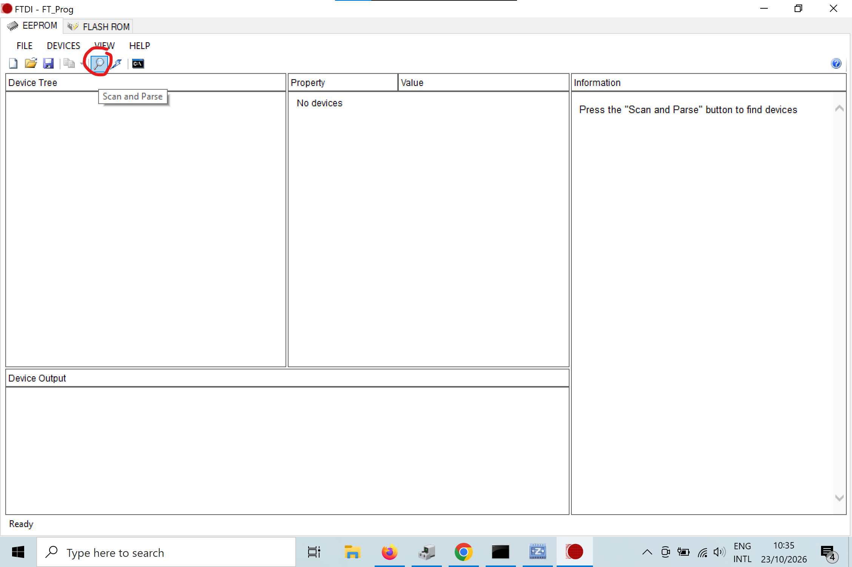
3. Right click the newly appeared device and click Apply Template > From File and select the provided “Icepi-Zero-FTDI-Chip.xml”

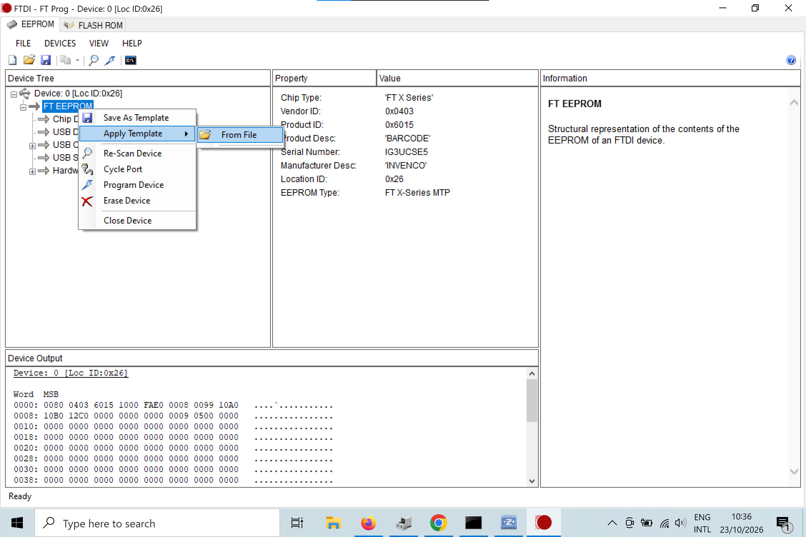
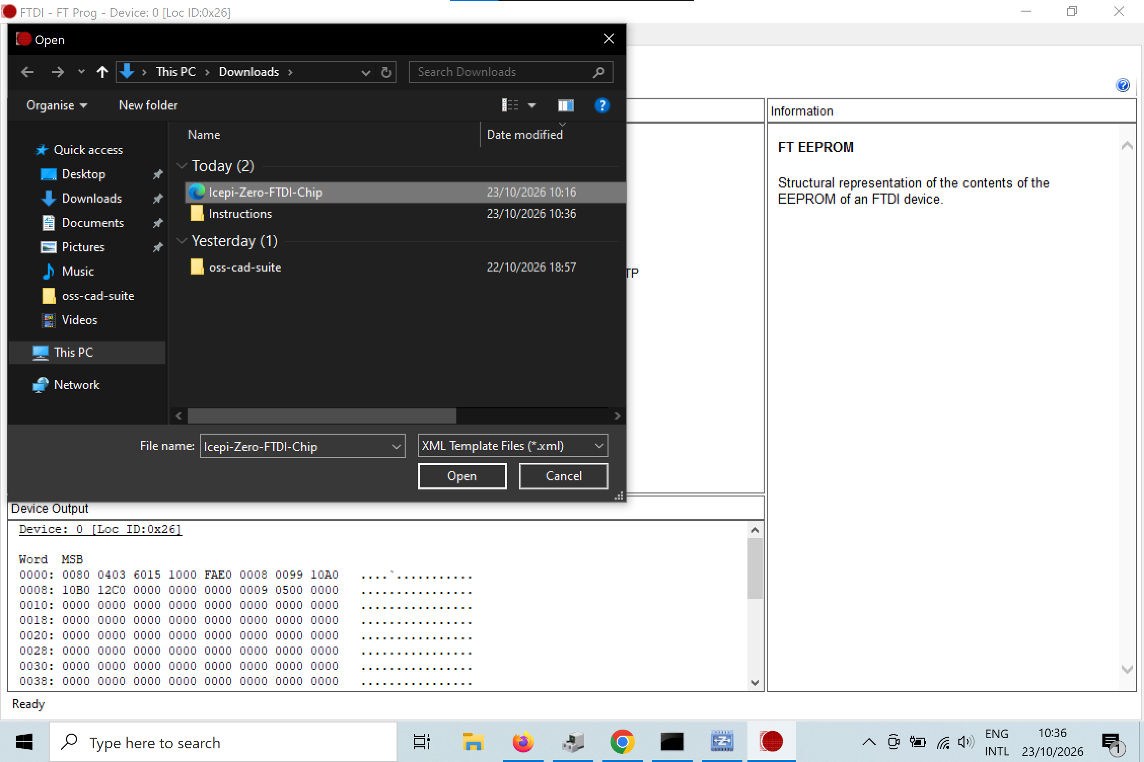
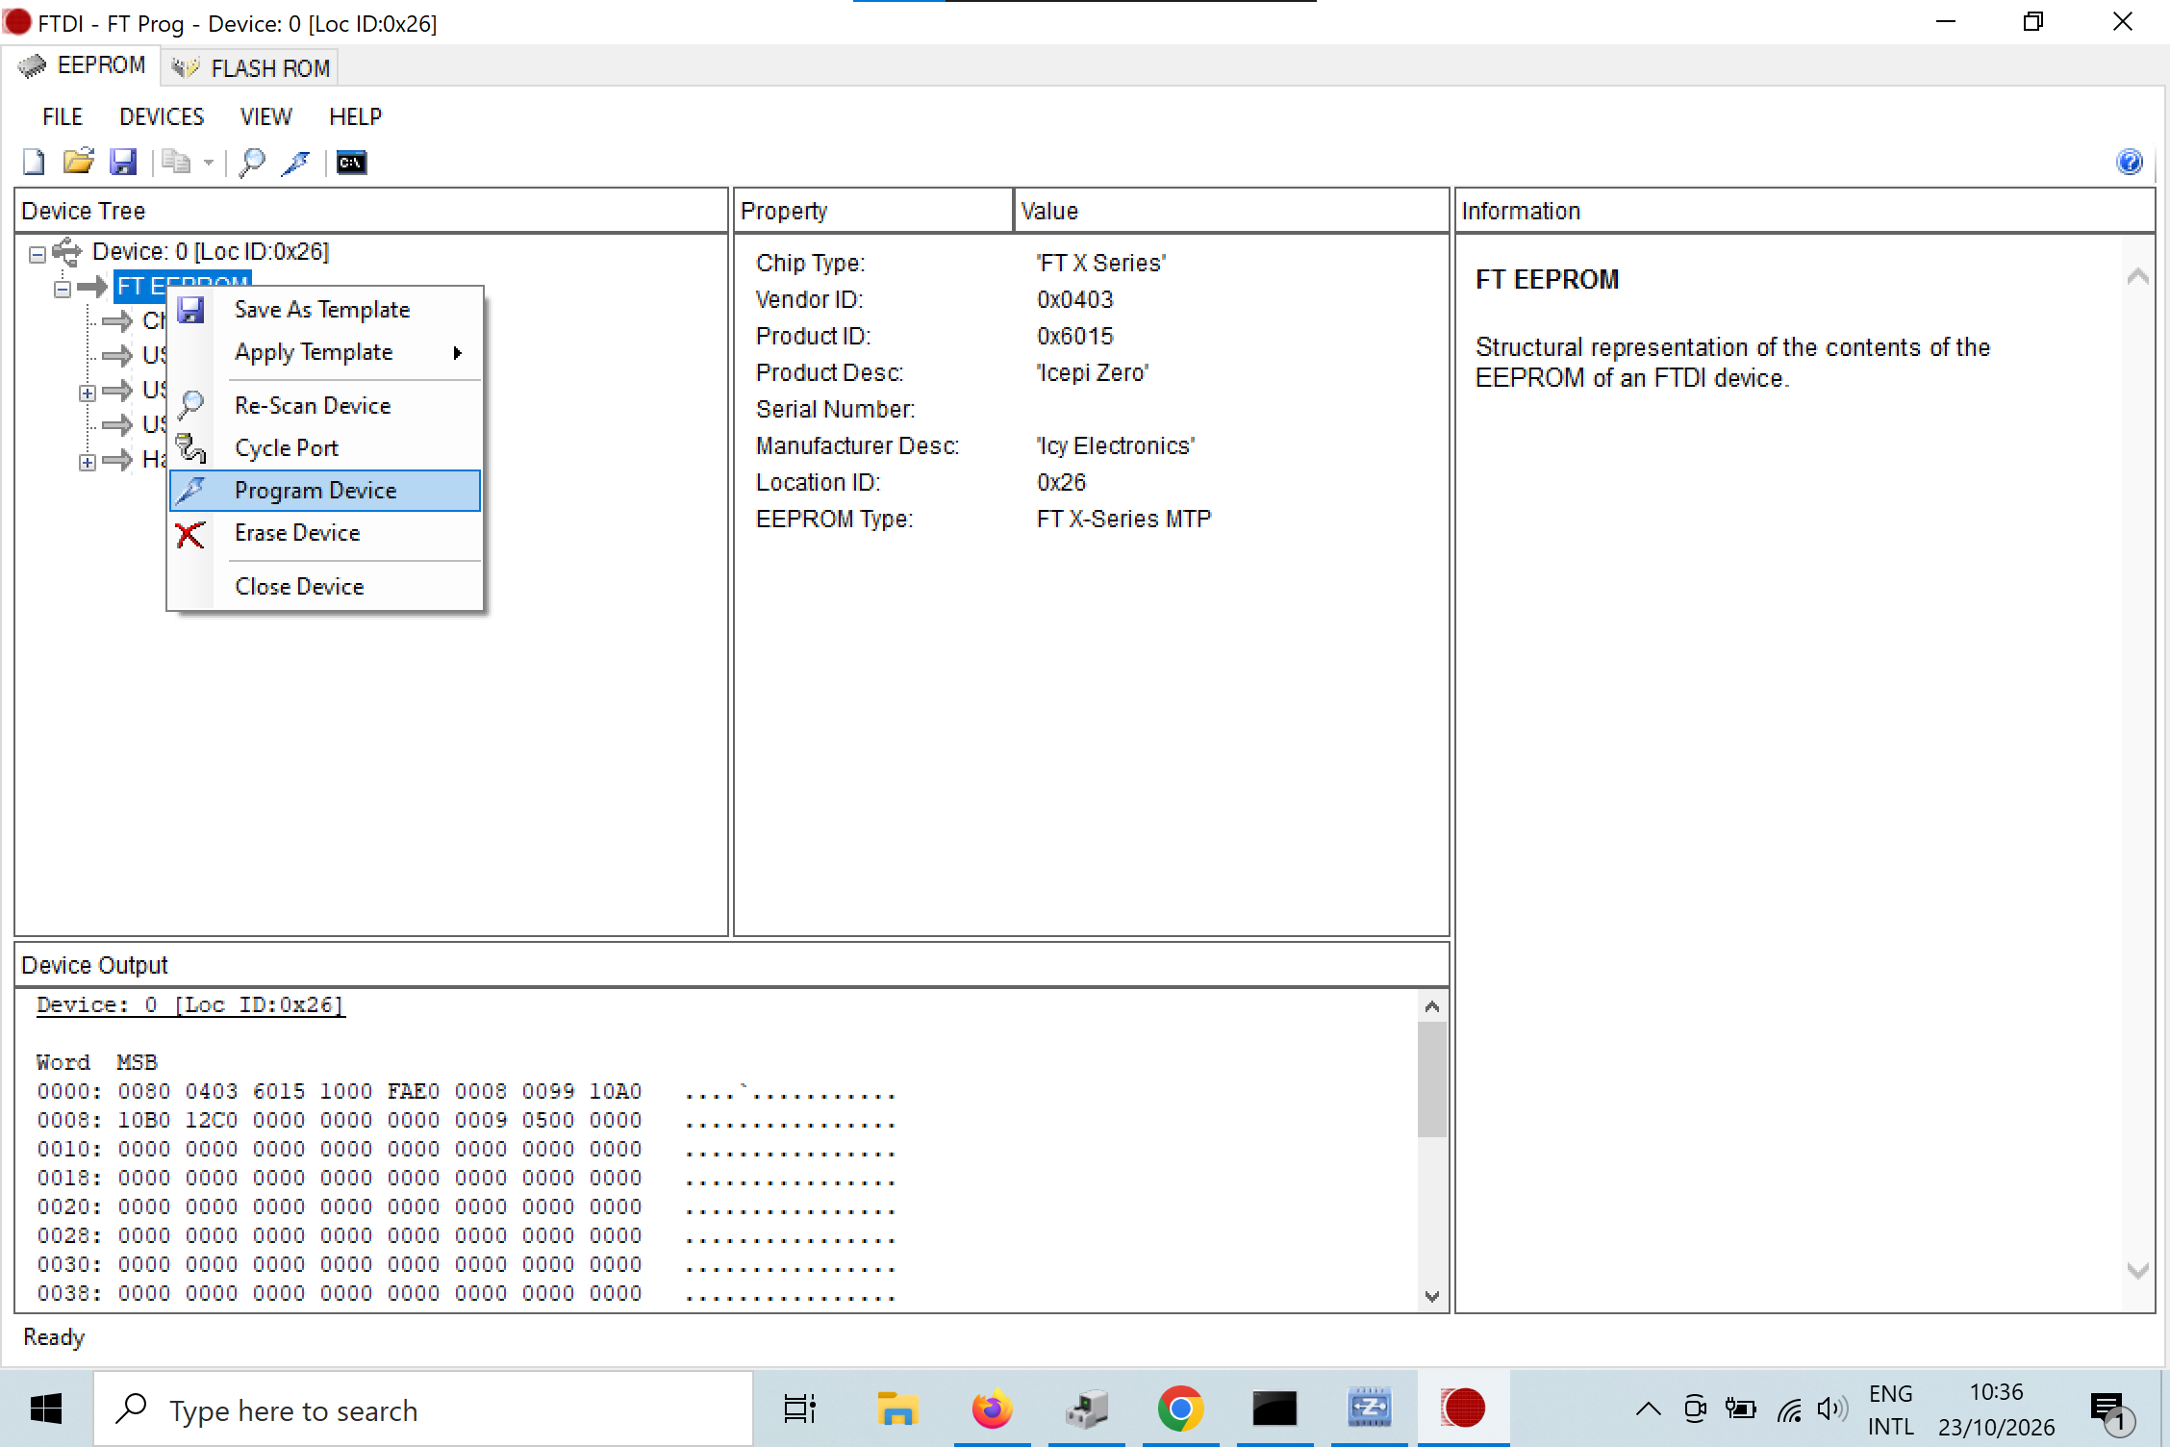
4. Right click the FT EEPROM device and click program device, then cycle port
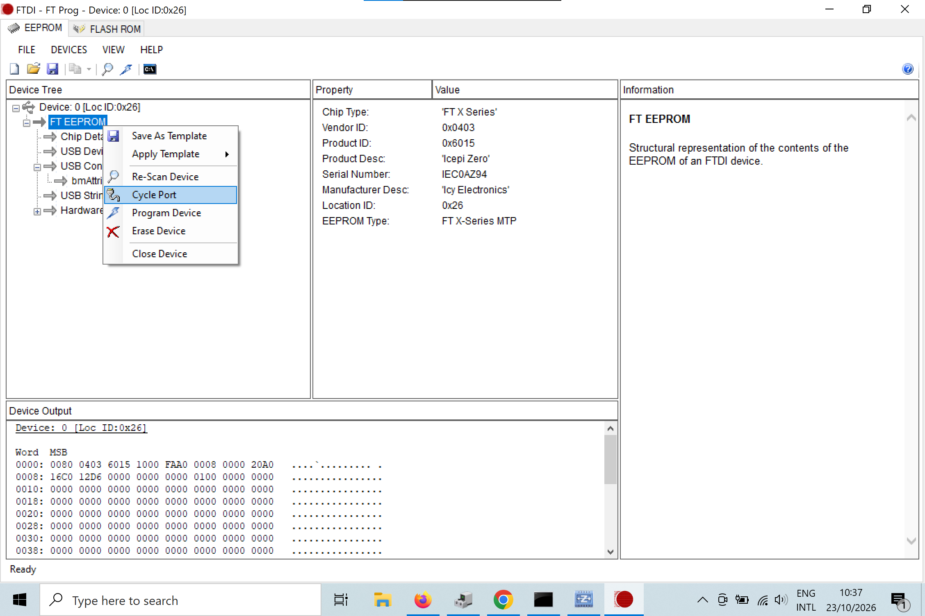
5. Open Zadig, select Icepi Zero (You may need to go into Options and check show all USB devices), then select WinUSB on the right side of the green arrow. Click Replace Driver. This might take 20-30 seconds
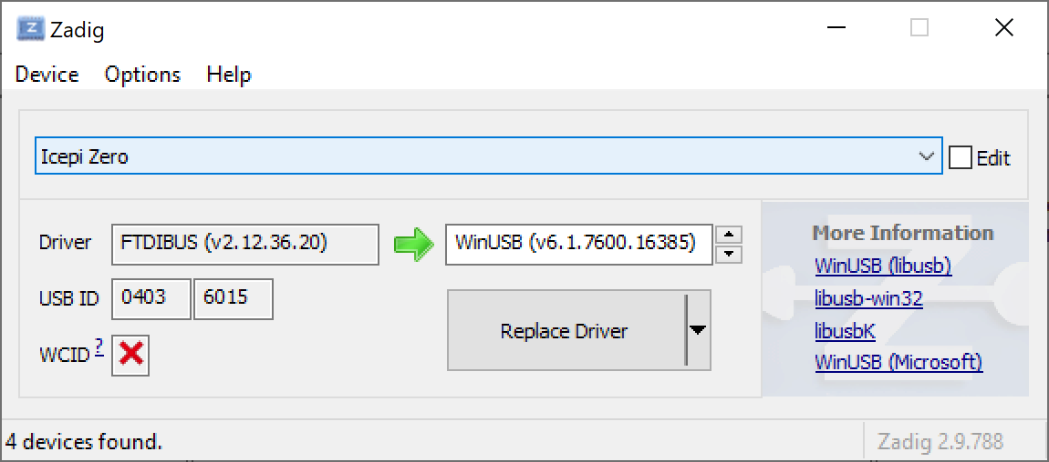
6. Open https://ofl.trabucayre.com/ in Google Chrome (Firefox does NOT work). On the middle left, in the “Manual Operations” section, select the following arguments (Click “Choose File” and select the fire-v.bit file downloaded during setup)
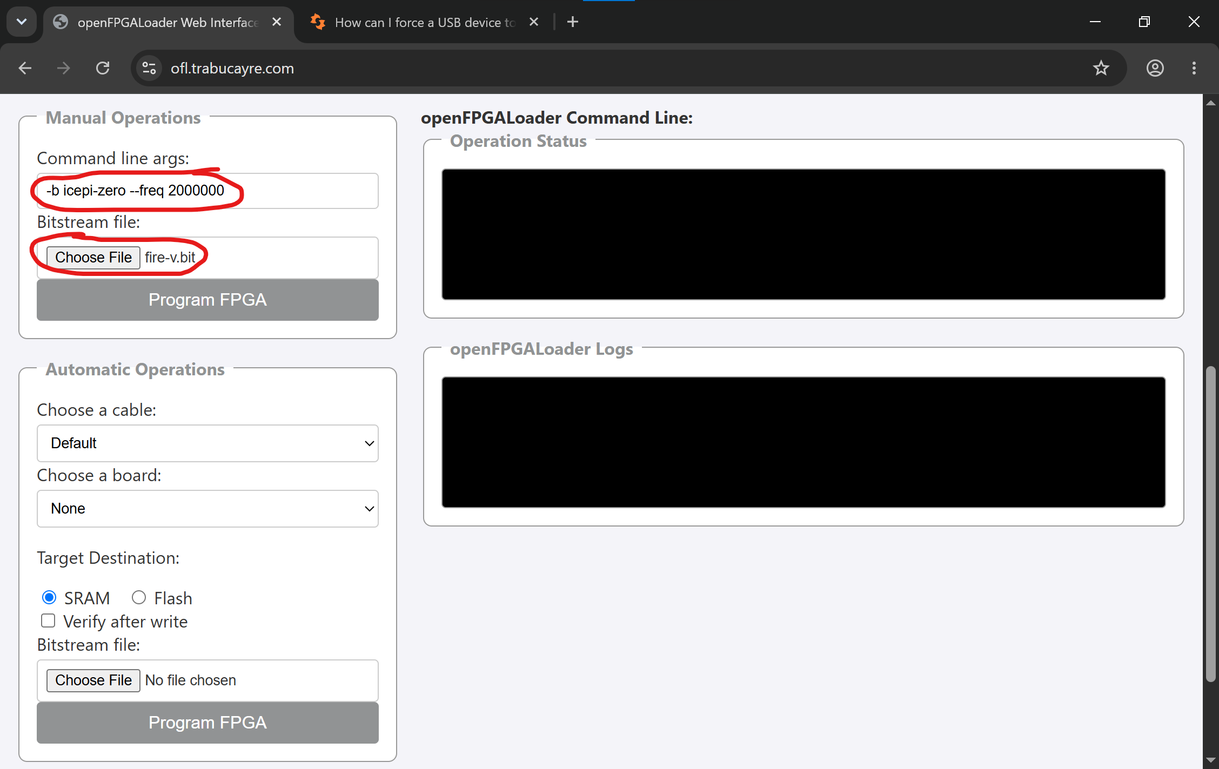
7. Click on “Program FPGA” in the Manual Operations section and select “Icepi Zero” in the popup menu and click connect:
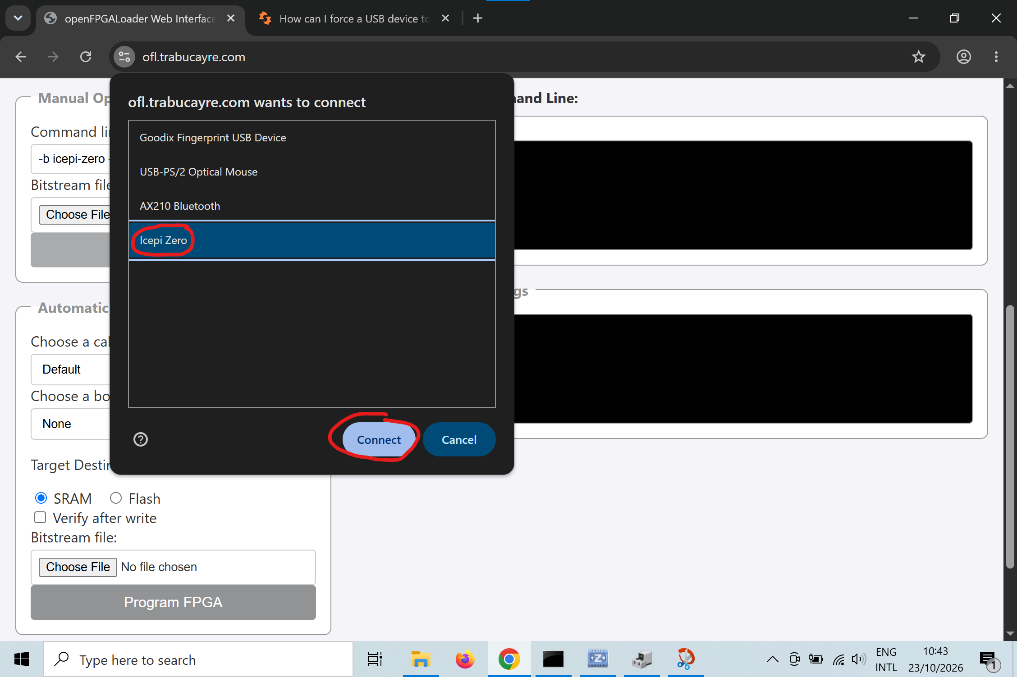
8. Wait for a few seconds, “Done” should be written in “openFPGALoader Logs”:
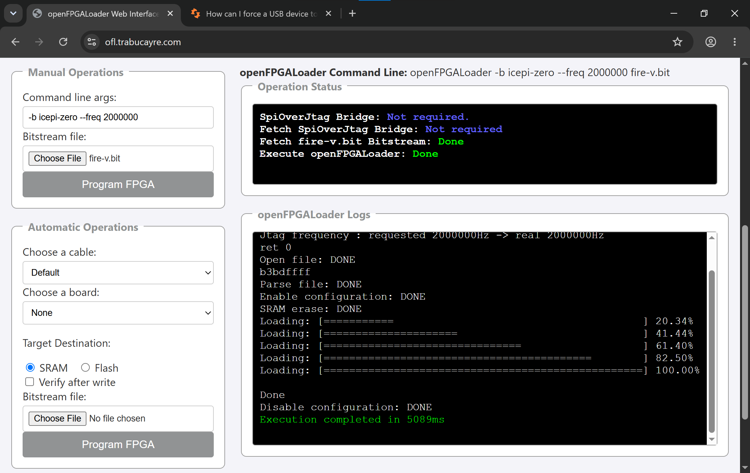
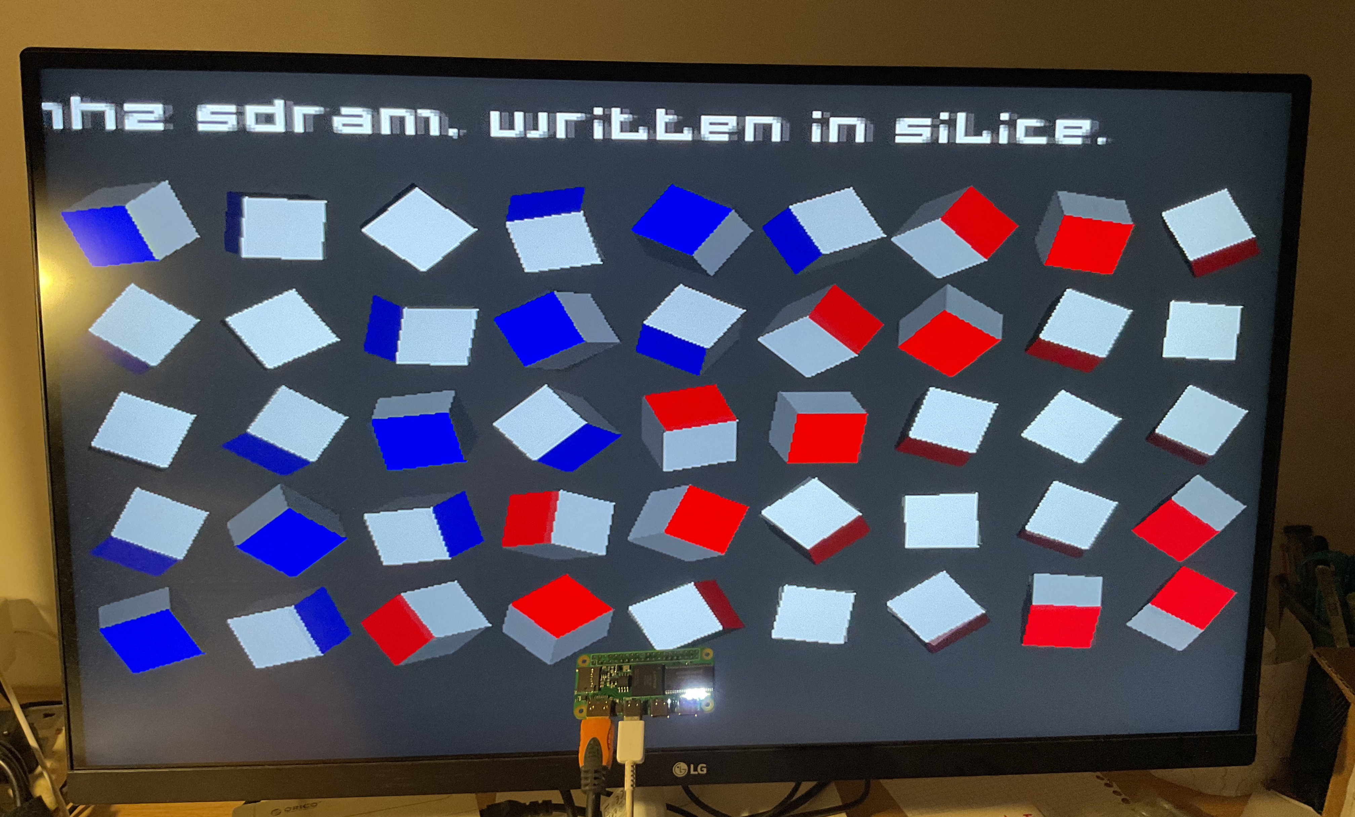
7. If the PCB works, you should see all the LEDs blinking and the following HDMI output on the monitor:

